create database health_analysis;

use health_analysis;

show tables;

desc `hospitalisation details`;

desc `medical examinations`;

select * from `hospitalisation details`;

select * from `medical examinations`;

select * from hospitalisation_details;

select * from medical_examinations;

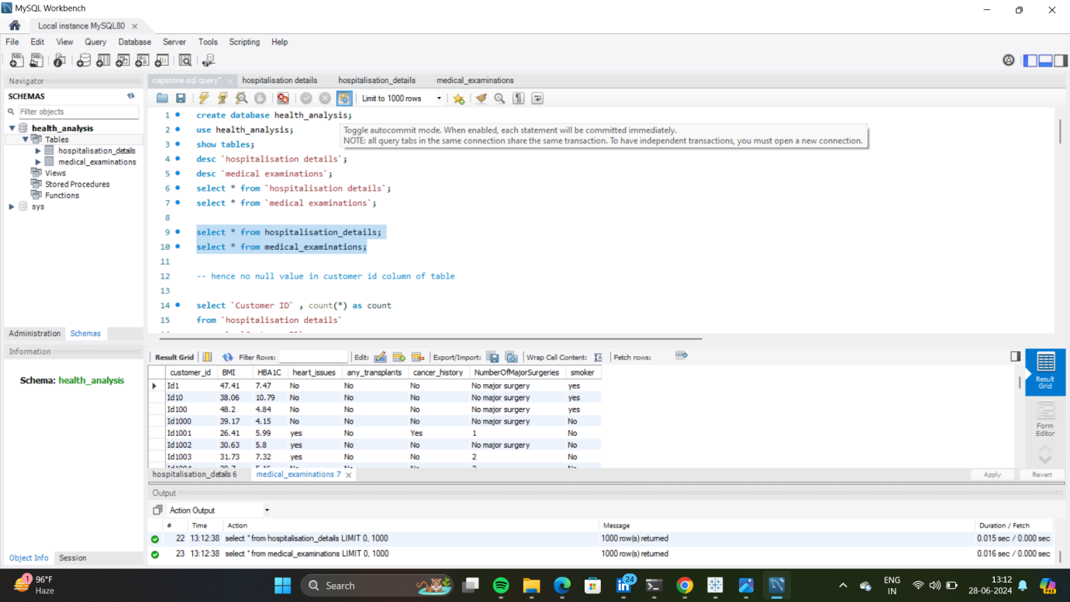

-- hence no null value in customer id column of table

select `Customer ID` , count(*) as count

from `hospitalisation details`

group by `Customer ID`

having count > 1;

SET SQL_SAFE_UPDATES = 0;

delete from `hospitalisation details`

where `Customer ID` = '?';

select `Customer ID` from `hospitalisation details`

where `Customer ID`= '?';

-- know we conclude that no null value and no duplicate values

desc `hospitalisation details`;

-- Rename the table

RENAME TABLE `hospitalisation details` TO hospitalisation_details;

RENAME TABLE `medical examinations` TO medical_examinations;

desc hospitalisation_details;

desc medical_examinations;

-- rename column to remove space between them for a better analysis

alter table hospitalisation_details

rename column `Customer ID` to customer_id;

alter table hospitalisation_details

modify column customer_id varchar(255);

alter table hospitalisation_details

rename column `Hospital tier` to hospital_tier;

**Healthcare Insurance Analysis**

alter table hospitalisation_details

rename column `City tier` to city_tier;

alter table hospitalisation_details

rename column `State ID` to state_id;

desc hospitalisation_details;

select * from medical_examinations;

alter table medical_examinations

rename column `Customer ID` to customer_id;

alter table medical_examinations

modify column customer_id varchar(225);

alter table medical_examinations

rename column `Heart Issues` to heart_issues;

alter table medical_examinations

rename column `Any Transplants` to any_transplants;

alter table medical_examinations

rename column `Cancer history` to cancer_history;

-- Adding primary key to customer by checking null and duplicate values

select customer_id

from hospitalisation_details

where customer_id is null;

-- not found Null value in customer_id

-- apply primary key function

alter table hospitalisation_details

add constraint pk_customer_id primary key (customer_id);

alter table medical_examinations

add constraint pk_customer_id primary key (customer_id);

-- merging the tables

select * from hospitalisation_details hd

inner join medical_examinations me

on hd.customer_id = me.customer_id;

/* Q.2 Retrieve information about people who are diabetic and have heart problems with their average

age, the average number of dependent children, average BMI, and average hospitalization costs */

select me.HBA1C, me.heart_issues, avg(me.BMI), avg(hd.children), avg(hd.charges) from hospitalisation_details hd

inner join medical_examinations me on hd.customer_id = me.customer_id

where me.HBA1C > 6.5 and me.heart_issues = 'yes'

group by me.HBA1C, me.heart_issues;

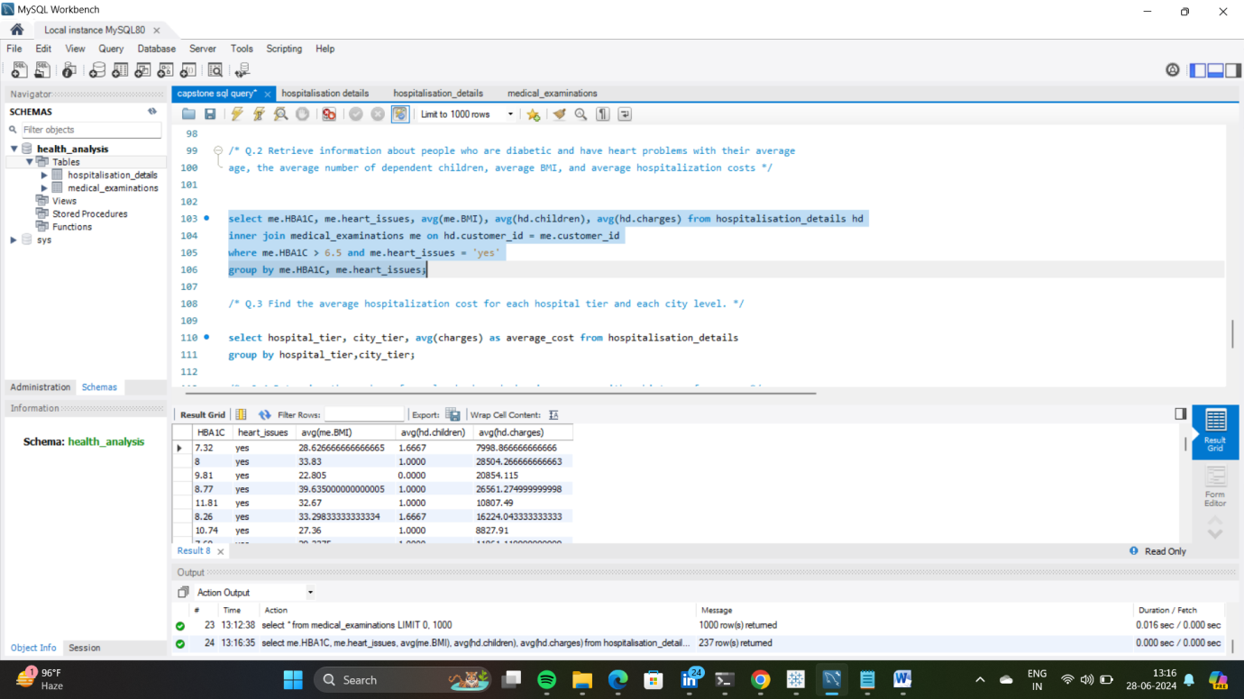

/* Q.3 Find the average hospitalization cost for each hospital tier and each city level. */

select hospital_tier, city_tier, avg(charges) as average_cost from hospitalisation_details

group by hospital_tier,city_tier;

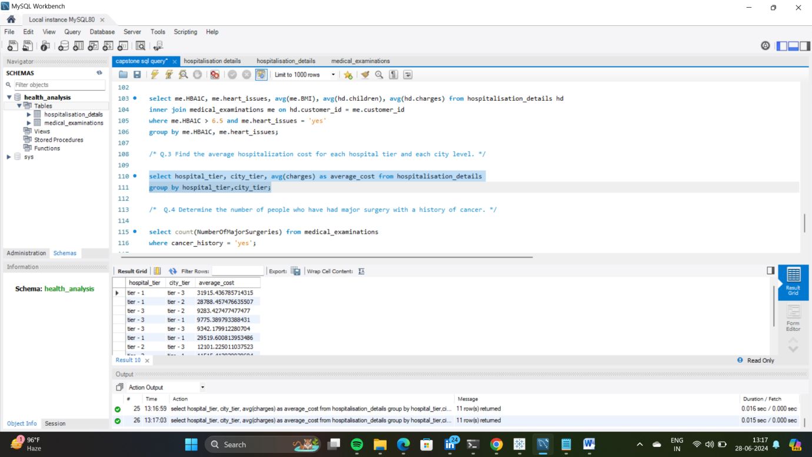

/* Q.4 Determine the number of people who have had major surgery with a history of cancer. */

select count(NumberOfMajorSurgeries) from medical_examinations

where cancer_history = 'yes';

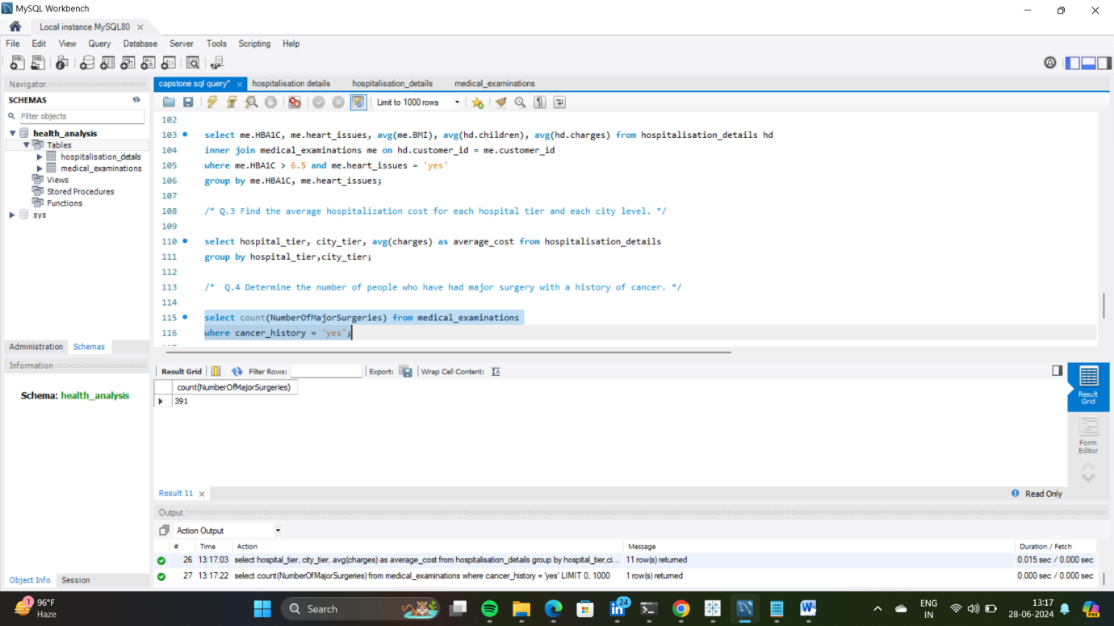

/* Q.5 Determine the number of tier-1 hospitals in each state*/

select state_id, count(hospital_tier) as tier1_hospital from hospitalisation_details

where hospital_tier = 'tier - 1'

group by state_id;

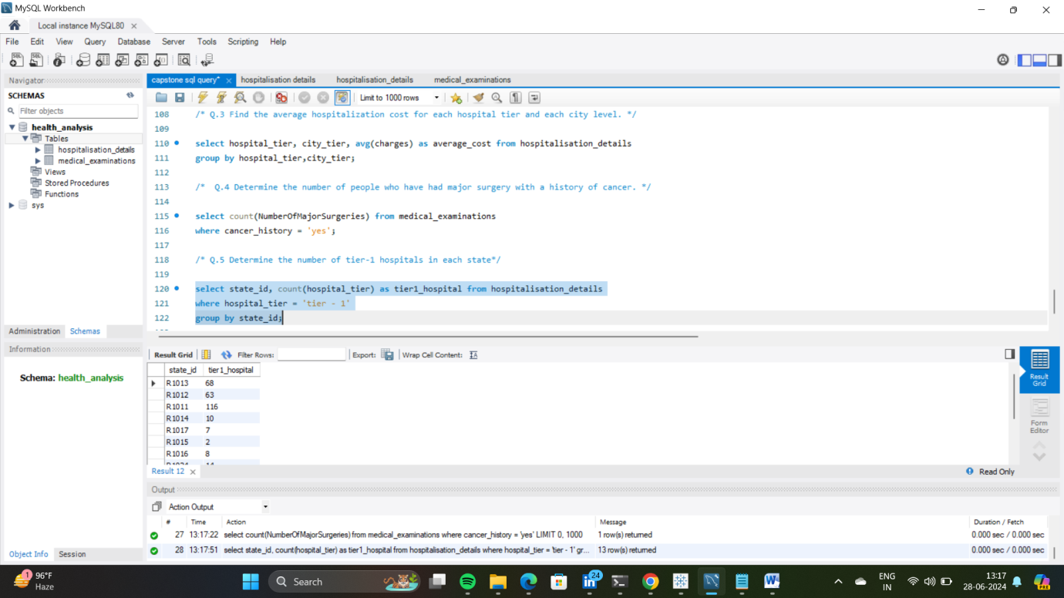

commit;

------------- END --------------